# Worksheet 6 PageRank

Activity 1:

PageRank is a method of presenting search results in order of relevance. The formula for PageRank is:

**PR(A) = (1-d) + d (PR(Ti)/C(Ti) + … + PR(Tn)/C(Tn))**

* **PR(A)** is the PageRank of page A
* **PR(Ti)** is the PageRank of pages **Ti** which link to page **A** (start by assuming it is 1)
* **d** is the damping factor (start by assuming that it is 0.85)
* **C(Ti)** is the number of outbound links on page **Ti**

The more we iterate the formula, the more accurate the PageRank. Assume that the initial PageRank for each web page is 1.

1. Using the PageRank algorithm, calculate the PageRank for the web pages listed in the following scenarios. You must show your working to **five iterations.** Rank the web pages in order of relevance based on your findings.

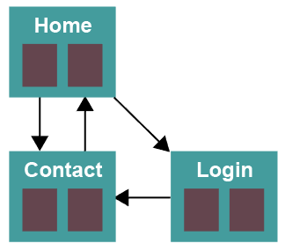

PR(H) = (1-0.85) +0.85(1/1) = 1

PR(C) = (1-0.85) + 0.85((1/2) + (1/1)) = 1.425

PR(L) = (1-0.85) + 0.85(1/2) = 0.575

PR(H) = (1-0.85) + 0.85(1.425/1) = 1.36125

PR(C) = (1-0.85) + 0.85((1.36125/2) + (0.575/1)) = 1.21728125

PR(L) = (1-0.85) + 0.85(1.36/2) = 0.728

PR(H) = (1-0.85) + 0.85(1.22/1) = 1.19

PR(C) = (1-0.85) + 0.85((1.19/2) + (0.728/1)) = 1.27

PR(L) = (1-0.85) + 0.85(1.19/2) = 0.66

PR(H) = (1-0.85) + 0.85(1.27/1) = 1.23

PR(C) = (1-0.85) + 0.85((1.23/2) + (0.66/1)) = 1.23

PR(L) = (1-0.85) + 0.85(1.23/2) = 0.67

PR(H) = (1-0.85) + 0.85(1.23/1) = 1.20

PR(C) = (1-0.85) + 0.85((1.2/2) + (0.67/1)) = 1.23

PR(L) = (1-0.85) + 0.85(1.2/2) = 0.66

Contact page first

Home page second

Login page third

* The Home Page links to the Contact Us page and Login page
* The Contact Us page links to the home page
* The Login page links to the Contact Us page

1. Using the PageRank algorithm, calculate the PageRank for the web pages listed in the following photography website. Show your working to **five iterations.** Rank the web pages in order of relevance based on your findings.

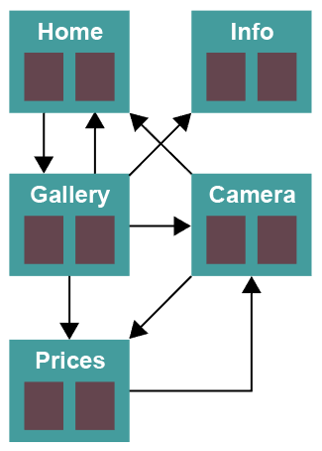

* The Home page links to the Gallery page
* The Gallery page links to the Home, Information, Prices and Camera pages
* The Prices page links to the Camera page
* The Information page has no outbound links
* The Camera page links to the Home page and the Prices page

PR(H) = 0.15 + 0.85((1/3)+(1/2)) = 0.86

PR(G) = 0.15 + 0.85(0.86/1) = 0.881

PR(P) = 0.15 + 0.85((0.881/4)+(1/2)) = 0.76

PR(C) = 0.15 + 0.85((0.881/4)+(0.76/1)) = 0.98

PR(I) = 0.15 + 0.85(0.881/4) = 0.34

PR(H) = 0.15 + 0.85((0.881/4)+(0.98/2)) = 0.75

PR(G) = 0.15 + 0.85(0.75/1) = 0.79

PR(P) = 0.15 + 0.85((0.79/4)+(0.98/2)) = 0.73

PR(C) = 0.15 + 0.85((0.79/4)+(0.73/1)) = 0.94

PR(I) = 0.15 + 0.85(0.79/4) = 0.32

PR(H) = 0.15 + 0.85((0.79/4)+(0.94/2)) = 0.72

PR(G) = 0.15 + 0.85(0.72//1) = 0.76

PR(P) = 0.15 + 0.85((0.76/4) + (0.94/2)) = 0.71

PR(C) = 0.15 + 0.85((0.76/4)+(0.71/1)) = 0.92

PR(I) = 0.15 + 0.85(0.76/4) = 0.31

PR(H) = 0.15 + 0.85((0.76/4)+(0.92/2)) = 0.70

PR(G) = 0.15 + 0.85(0.7/1) = 0.75

PR(P) = 0.15 + 0.85((0.75/4)+(0.92/2)) = 0.70

PR(C) = 0.15 + 0.85((0.75/4) + (0.70/1)) = 0.90

PR(I) = 0.15 + 0.85(0.75/4) = 0.31

PR(H) = 0.15 + 0.85((0.75/4) + (0.9/2)) = 0.69

PR(G) = 0.15 + 0.85(0.69/1) = 0.74

PR(P) = 0.15 + 0.85((0.74/4)+(0.90/2)) = 0.69

PR(C) = 0.15 + 0.85((0.74/4)+(0.69/1)) = 0.89

PR(I) = 0.15 + 0.85(0.74/4) = 0.31

Camera page first

Gallery page second

Home page third (unrounded slightly above prices page)

Prices page fourth (unrounded slightly below home page)

Info page fifth